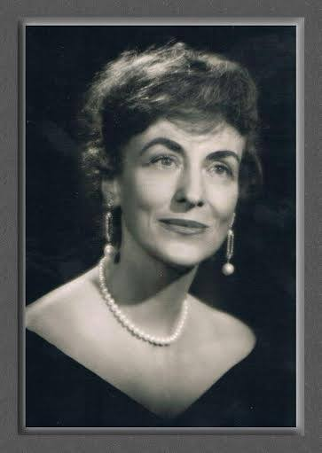
Marvel (Rasmussen) Ritter Zona
Born: 1919?
Death: July 15, 2015

The transcript of this interview has no title page. It was probably conducted in the early 1990s by Jean Hainer, while she was visiting Marvel in Florida. Marvel had moved to Florida from Grand Rapids, MI, probably about 30 years before this interview. The focus of their conversation was the work that Marvel did, while living in Grand Rapids, with Displaced Persons immediately after WWII.
Marvel was born in Greenville, MI. She was the daughter of the “war time” mayor and granddaughter of August Rasmussen, who was the “founder of the Scandinavian community.” He was also the author of a book that chronicled the settlement of Greenville. “When he came to this country from Denmark, he and his wife came alone. But a year later, as a result of his letters back to Denmark, 40 of their friends arrived. That was the nucleus. So what starts as a little acorn may grow into a substantial oak,” said Marvel.
Her grandfather’s leadership may have been Marvel’s inspiration when, in 1946, she volunteered to sponsor five families from Latvia. Yet she explained her motivation to help Displaced Persons as a manifestation of “her compassion.” After meeting her former husband, Arel Ritter, through her work as a live-in governess for his two children, the couple had their own two boys, one of which was mentally handicapped. “He was instrumental in [Marvel] becoming a charter member of the Lincoln School Foundation for mental retardation.”
Moreover, Marvel learned that Displaced Persons were not allowed into America “if there was a health problem of any nature.” When she learned of the Latvian situation from a young Methodist minister, Marvel offered to sponsor the first five families. In this interview Marvel described how she organized and managed this project as it grew from those few families to over 200 families.
Marvel emphasized that she was not alone in her compassion for those people. Others helped such as “. . . committees from the churches, local residents who were interested and called in and wanted to help. So I feel very grateful and admire the citizens of Grand Rapids who opened their hearts and their minds to the plight of the displaced persons.”
On the other hand, Marvel spoke highly of the Latvian people who came to Grand Rapids. “. . . we can all be very proud of [them]. They are people of immense integrity and ambition. They paid back the price of their fare. They fulfilled their obligation to their employers. They have built and bought homes in Grand Rapids area. They are a credit to the city.”
When she reflected on her experience and what it meant to her at the time of the interview, Marvel said, “It’s important our youth realize [that there is less freedom in other countries, particularly those in and near Russia]; [they should] cherish their American citizenship; [they should] take nothing for granted and appreciate what it means to be a citizen of the United States. It seems patriotism will once again be reborn as a result of the Persian Gulf conflict.”
Marvel attended Olivet College and National College of Education, in Evanston, IL, “where [her] dream had been to be an employee or social worker at Hull House.” She majored in Child Psychology.
In a letter to Jean Hainer, which she read into the transcript, Marvel wrote about what this interview meant to her: “I feel the bottom line of this interview is that as long as we live, life is a beautiful gift, one of eternal growth, lessons to be learned, and cherished, and although formal education may end in the classroom, the education process never ends.”
Other Resources:
https://www.facebook.com/HoweyMansion/posts/1168763246474599
http://www.corporationwiki.com/Florida/Winter-Park/marvel-r-zona-1719658.aspx
https://www.myheritage.com/names/marvel_zona

